Golden Plains Shire Standpipes
Council operates nine mains connected standpipes and four public accessible bores across the municipality to provide water for stock and domestic supply.
Access to the standpipes operates on a permit system. Residents can purchase a permit from the permit provider for $30 (2020/21 price) which allows the permit holder to take up to 5000 litres of water over the period of one month.
The standpipes are connected to the reticulated water supply systems operated by Central Highlands Water and Barwon Water. This is drinking quality water and has to be used in line with the water restrictions enacted by the respective water authorities at the time of taking the water.
The bores at Wallinduc, Cape Clear and Warrambine are for stock and firefighting supply only. The Napoleons Bore is currently not in operation.
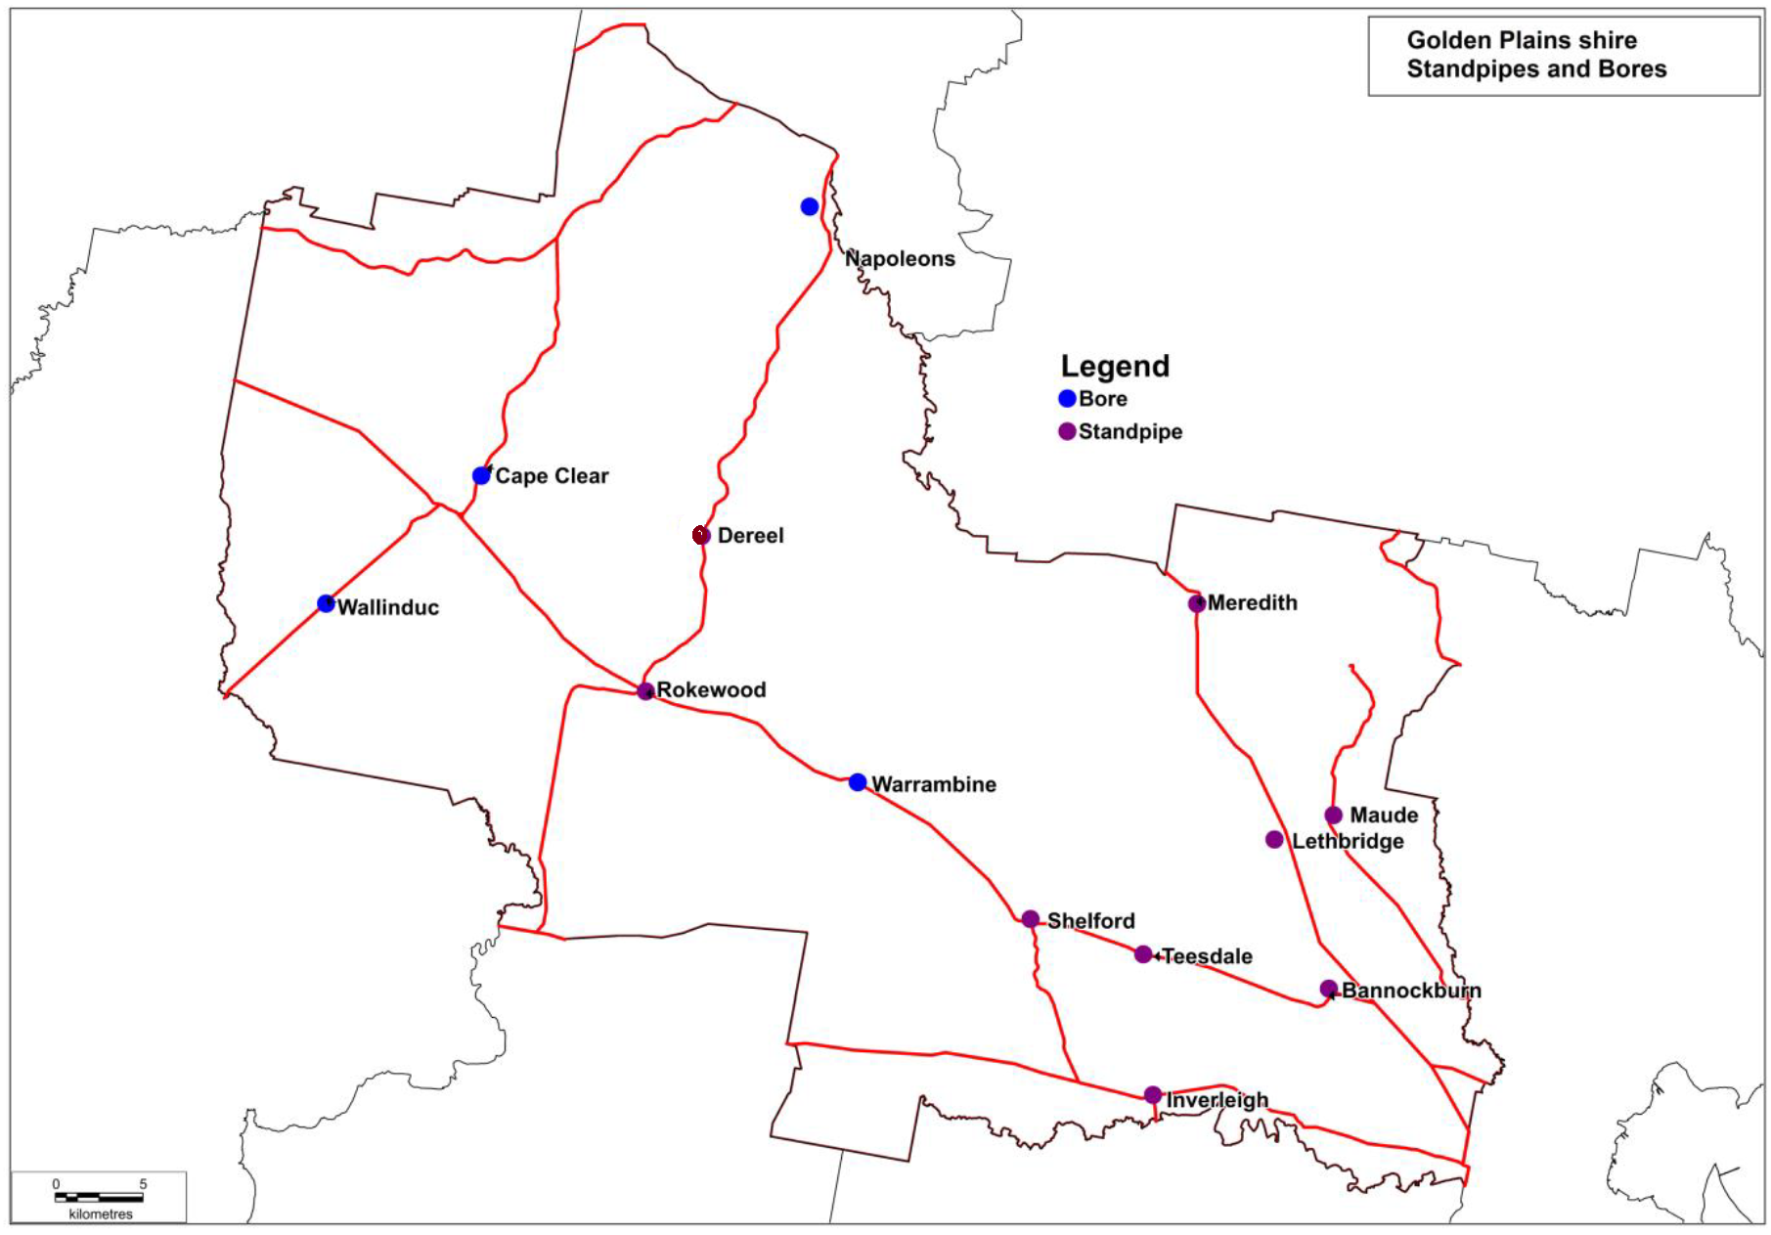
Continued next page

Town | Standpipe Location | Permit & Key Provider
Bannockburn | McPhillips Road | B&S Stockfeeds, 12 Milton St, Bannockburn
Dereel | Swamp Road near the Dereel Hall | Jennifer King 12 Grevillea Road Dereel  0419 673 595
Inverleigh | Dundas St between Cambridge and High Streets | Riordan’s Fuel Stop, 19 High St, Inverleigh
Lethbridge | Corner of Russell and Ackland Streets | Lethbridge General Store, 1 Russell St, Lethbridge
Maude | Thompson Road near the intersection with Steiglitz Road | 14 Perdrisat Road, Maude
Meredith | Wilson Street opposite the Meredith Roadhouse | Meredith Roadhouse, 26 Wallace St, Meredith
Rokewood | Near Rokewood Memorial Hall on Ferrars Street | Rokewood General Store, 67 Ferrars Street, Rokewood
Shelford | Ormond Street near the tennis courts | Teesdale General Store, 1071 Bannockburn-Shelford Road, Teesdale
Teesdale | Pantics Road near the intersection with the Bannockburn-Shelford Road | Teesdale General Store, 1071 Bannockburn-Shelford Road, Teesdale
Theft of water from standpipes places an unfair burden on the rest of the community as it is reasonable to expect ratepayers and honest users to cover the cost of this water. Theft of water will be reported to the authorities.

