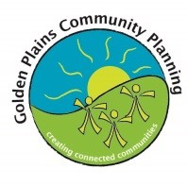
Linton Community Plan
What is Community Planning?  Community planning is a process where community members come together and take action to improve their community. Community members develop a Community Plan that outlines projects they will undertake to make their town a better place to live.  Golden Plains Shire Council supports community planning by providing a professional facilitator who assists communities, as well as grants to help implement the projects in the Community Plan.  Currently 22 communities across the Shire are helping make their towns a great place to live through community planning. To learn more about community planning visit the goldenplains.vic.gov.au.  Community Coordinators  Local residents known as Community Coordinators, volunteer their time to coordinate the development and implementation of a community plan for their community. The following community members are Community Coordinators for this Linton Community Plan.  Marlene Barrow: 0409 520 669  Kirsty Clark: 0419 116 78 kandjclark@optusnet.com.au  Julie Eaton: 0403 318 825 busymum57@hotmail.com  Ian Forrester: 0429 694 011 forrester.ian.i@edumail.vic.gov.au  Karen Ronan: 0409 026 310 mkronan1@bigpond.com  Halina Sztynda: 0439 343 475 hsztynda@gmail.com  Kylie Turville: 0448 428 190 k.turville@iinet.net.au  Joy McDonald: 0490176401 jam@goonly.net  Robyn Jordan: 0490124766 goldfieldfinds@gmail.com  Warren Bowen: Warrenbowen1979@gmail.com  Pam Farey: farey@vic.chariot.net .au  Nina Swanson: ninas_email_place@hotmail.com  Andrea Smith: andcs@live.com  Please contact your Coordinators for more information about this Plan or for the date of upcoming meetings that you are welcome to attend. | Date plan was adopted 24 February 2016  Plan start date 28 February 2016  Plan finish date 24 February 2019  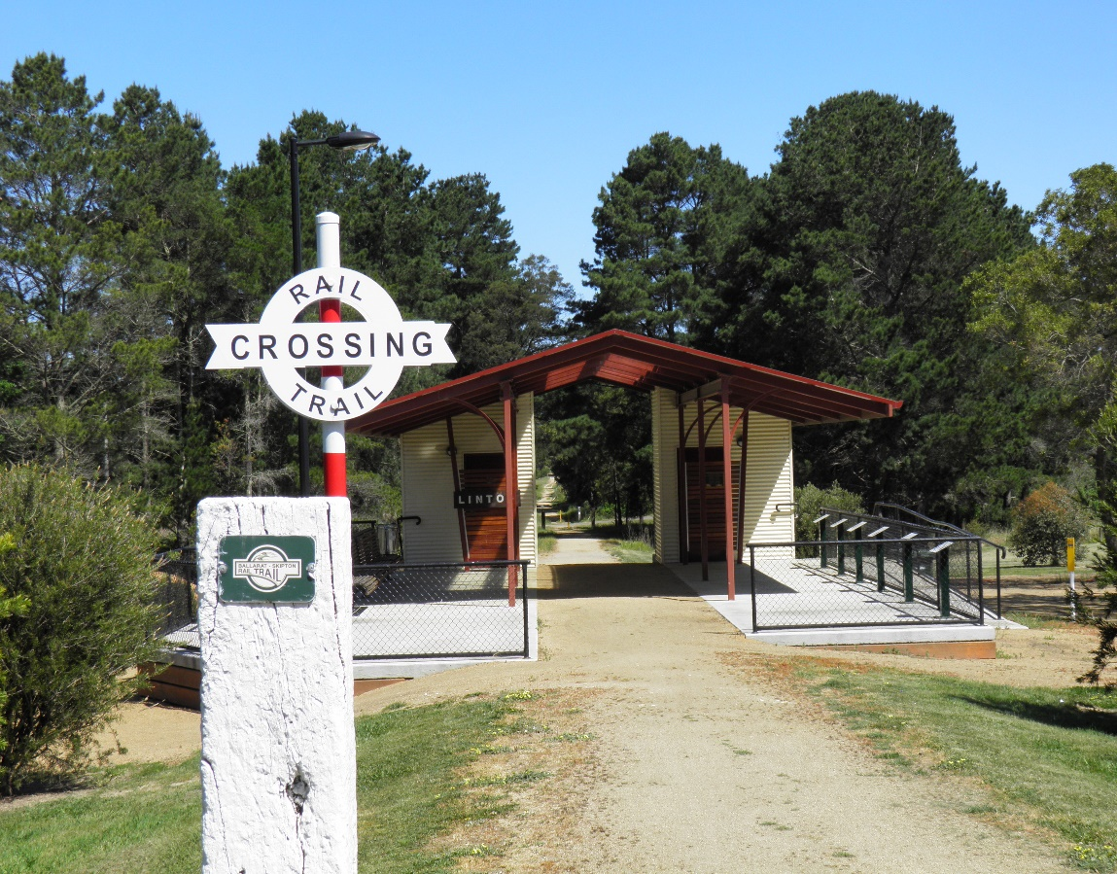  Summary of previous achievements  Many Linton residents and local partners have worked together to implement Linton Community Plans. Together they achieved a lot including:  - The Station Precinct  - The BMX Track  - The Skate Park  - Installation of township ‘what’s on sign’  - Overtaking lanes (Cherry Tree Hill)  - Community Events (eg Christmas in July; Spring Carnival)  - Community Playground at Linton Primary School | “We couldn’t be prouder of Golden Plains Shire Community Coordinators, and everyone involved in community planning – they go above and beyond for their communities and they’re a big reason why Golden Plains is such a great place to live and visit.”  Cr Des Phelan, Mayor  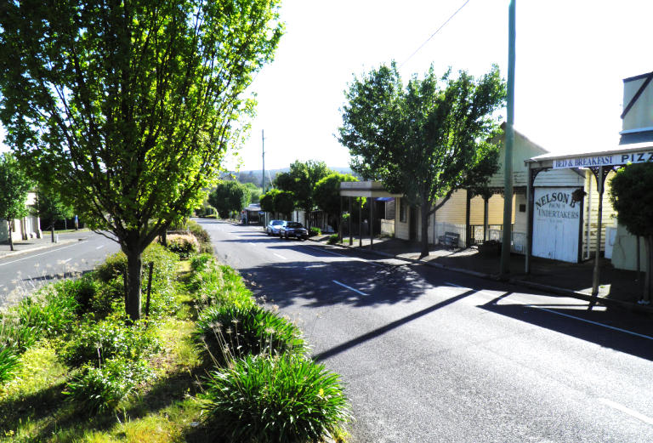  How was this Plan developed?  Preparation to develop this Community Plan started in September 2015. The Linton community were asked for ideas and projects via a survey, interviews and public meetings. Two public meetings were held in November of 2015 to vote on ideas gathered in the surveys and interviews.  Over 75 Linton residents contributed to the development of this community plan. Women, men, children and many community groups were involved.

2016-2019 Community Plan Key Projects
- New Social Groups and Clubs  Support the development of new social groups and clubs to increase social connectedness and decrease social isolation in the Linton community. This project will specifically aim to develop clubs that benefit the following Linton residents:  - young parents (playgroup)  - young people  - elders in the community  SEED funding allocated to this project: $500  - Restore & Repurpose Heritage Buildings  Work with the Historical Society to access funding to support the restoration and repair of Linton’s heritage buildings such as the Linton Library and Undertakers buildings. The project will also work to repurpose heritage buildings for local events such as exhibitions and museums so the buildings get maximum use.  SEED funding allocated to this project: $500  - Event for the Town  Support and facilitate events for the people of Linton and surrounding areas. Specifically this project will;  - Work in partnership with the school to celebrate the 150th Anniversary on 1st August 2017.  - Develop and implement a community joint fundraising event, whereby profits can be allocated to support various community groups / initiatives (as opposed to one single group / initiative) – promoting cross community collaboration.  - Review past events, with the view to facilitating a specific social event to bring the community together (eg music event; rock n roll dance) – run by the community, for the community.  SEED funding allocated to this project: $2000  The Linton Community Plan is proudly supported by |  | 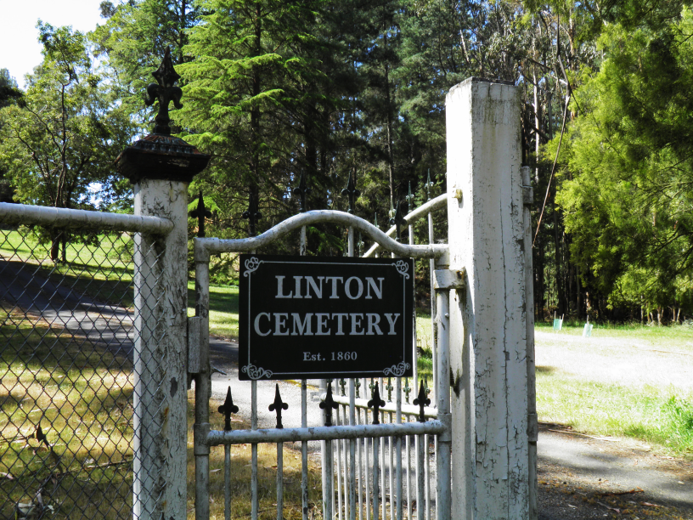  - Community Garden  Develop a Community Garden Model to meet the specific needs of the Linton community. This community garden project may include expanding the school food garden, developing a food network, revitalising horse troughs and addressing the street scape.  SEED funding allocated to this project: $1000  - Men’s Shed  Support the establishment of the Linton & District Men’s Shed. The project will advocate for a permanent building / site and work in partnership and collaboration with the Men’s Shed to support ongoing activities.  SEED funding allocated to this project: $2000  - Safe Walkway from Hewitt’s Road  Advocate for a safe walkway or proper footpath from Hewitt’s Rd. Work with Vic Roads and Council on this project. |  | - Advocate for better fire risk reduction  Raise awareness at Community, Council and State Government levels regarding the risk hazard of dead wood within the Linton Forest and Council Land. Gain support from Community, Council and State Government to develop a risk reduction model that:  - allows community members to collect dead wood prior to a planned burn  - ensures community members are notified by Vic Roads when tree chopping is to occur so they can have the opportunity to collect wood  Work with Council to develop this model and have it endorsed by DWELP and Vic Roads.  - Mortchup Reservoir  Continue to support the ongoing implementation of the Mortchup Reservoir Plan. This includes:  - Community support for working bees to maintain the land (getting rid of weeds; planting etc.)  - Work towards construction of a Boardwalk and a Bridge on the Spillway (whether in supporting grant applications or joint projects with Men’s shed).  - Pop Up Town Using Vacant Spaces  Create and develop a “Pop Up Town” model to utilise vacant shops and spaces in the town. The model will consider:  - Frequency (monthly / quarterly / seasonally)  - Themes (markets; theatre; music)  The project will work with the whole community to identify how this may intersect with other community interests.  SEED funding allocated to this project: $1500  Disclaimer; If major changes to community plan projects need to be made within the life of the plan, Coordinators will conduct public process before making these changes
 | 2016-2019 Community Plan Key Projects
 | - New Social Groups and Clubs  EXAMPLE:  Support the development of new social groups and clubs to increase social connectedness and decrease social isolation in the Linton community. This project will specifically aim to develop clubs that benefit the following Linton residents:  - young parents (playgroup)  - young people  - elders in the community  SEED funding allocated to this project: $500  - Name of Project  Project Outline:  SEED funding allocated to this project:  Project Outline:  SEED funding allocated to this project:  The Community Plan Program is proudly supported by |  | Insert Photo  Project Outline:  SEED funding allocated to this project:  Project Outline:  SEED funding allocated to this project:  Project Outline:  SEED funding allocated to this project: |  | Project Outline:  SEED funding allocated to this project:  Project Outline:  SEED funding allocated to this project:  .  Project Outline:  SEED funding allocated to this project:  Disclaimer; If major changes to community plan projects need to be made within the life of the plan, Coordinators will conduct public process before making these changes

