Golden Plains Shire Council is inviting Expressions of Interest from community members who may like to join a Community Reference Group to help Council design and facilitate meaningful engagement with the wider GPS community members to inform the Community Vision 2040
What is Golden Plains Shire Community Vision 2040 project?
The Community Vision will directly influence the decisions and actions that we all take today and move us into the future. Once completed the Community Vision will provide direction for Council priorities and provide a course for united community led action. The document will set the vision for the type of community and place Golden Plains Shire will be in 2040.
What is a Community Reference Group?
The Community Reference Group (CRG) will work alongside Council Officers in the co-design of a range of methods that will attract and engage community members of all ages, towns and localities to this project. Methodology may include community workshop or online surveys, focus group and conversation posts, surveys, competitions or postcards. The CRG will assist Council in selecting approaches that will have the greatest reach and engagement. The membership of council’s Community Reference Group will be made up of a variety of community members from various locations within the Shire, across an age range, there will also be a cross section of Council staff involved in the various milestones in the project. Membership on a council Community Reference Group is voluntary.
The benefits of a community reference groups include:
- By working in partnership with Council you will have the ability to influence and shape the type of Community Golden Plains will be known as in 2040.
- Draw on your local knowledge and enhance the voice of your community to guide and advise Council on key issues and matters of importance.
- Build your understanding of Council’s core business functions and specific projects or activities.
- Participants will receive free “Engagement Essentials” training from renowned Engagement Training professionals IAP2.
- Meet other community members from across the Shire.
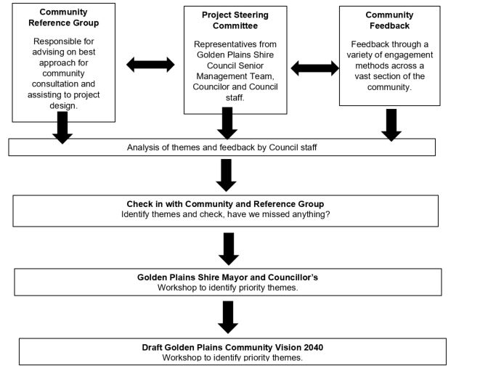
Interested community members are required to complete an EOI application to be considered for membership in the group. The EOI applications submitted will be assessed by a panel comprised of Council’s Director Community Services, a Councillor and Community Engagement Officer based on the eligibility criteria.
Before completing this application form, it is important that you read the Golden Plains Community Vision Community Reference Group Terms of Reference:
After reading the Terms of Reference, please tick sign and date the checklist below:
Checklist
- I have read the Golden Plains Community Vision Community Reference Group Terms of Reference.
- I understand that the Community Reference Group represents various opinions within the community.
- I understand that as a member of the Community Reference Group I cannot make comments to the media on behalf of Council or the Community Reference Group.
- I understand that the membership on the Community Reference Group is voluntary and I will not be paid or reimbursed for the time or costs related to my membership with the group.
EOI Application form:
PERSONAL DETAILS
Given Name:………………………………………. Surname:……………………………………..
Home/Company address: …………………………………………………………………………..
Suburb: ………………………………………. Postcode: ………………………………………….
Phone Number:………………………………………………………………….
Email address: …………………………………………………………………………………………
Gender: M F Other Prefer not to answer
Please circle the statement below which best describes your relationship with Golden Plains:
I live in the Golden Plains Shire
I work in the Golden Plains Shire
I am a land owner/ business owner in the Golden Plains Shire

Applicant Supporting Information.
Age: Under 18 18- 35 36- 55 55-69 70 and over
Briefly outline what specific skills or life experiences or groups you have been involved in that you would bring to the Community Reference Group.
………………………………………………………………………………………………………………………………………………………………………………………………………………………………………………………………………………………………………………………………………………………………………………………………………………………………………………………………………………………………………………………………………………………………………………………………………………………………………………………………………………
What do you love about Golden Plains Shire?
……………………………………………………………………………………………………………………………………………………………………………………………………………………………………………………………………………………………………………………………………………………………………………………………………………………………………………………………………………………………………………………………………………………………………………………………………………………………………………………………………………..
What do you think is the biggest issue that Golden Plains Shire residents are currently facing?
………………………………………………………………………………………………………………………………………………………………………………………………………………………………………………………………………………………………………………………………………………………………………………………………………………………………………………………………………………………………………………………………………………………………………………………………………………………………………………………………………………

What do you think is the benefit to you as an individual being involved in this process?
……………………………………………………………………………………………………………………………………………………………………………………………………………………………………………………………………………………………………………………………………………………………………………………………………………………………………………………………………………………………………………………………………………………………………………………………………………………………………………………………………………..

Privacy Statement Council will comply with the Information Privacy Principles as set out in the Privacy and Data Protection Act 2014. Council has in place a standard operating procedure that sets out the requirements for the management and handling of personal information. If you provide your email address via this site, it will only be used to respond to your specific enquiry. Your email address will not be added to any mailings lists/databases, or otherwise used without your knowledge or consent, unless specifically required by law. The Golden Plains Shire Council considers that the responsible handling of personal information is a key aspect of democratic governance, and is strongly committed to protecting an individual’s right to privacy. Council will comply with the Information Privacy Principles as set out in the Privacy and Data Protection Act 2014. Council has in place a standard operating procedure that sets out the requirements for the management and handling of personal information. If you have any queries regarding this Privacy Statement, please contact the Information Privacy Officer on 03 5220 7104. Council will receive personal information from you (or your authorised representative) via a range of means. Regardless of how it is collected, Council will use and disclose personal information:
- for the primary purpose for which is was collected;
- for a secondary purpose that an individual would reasonably expect;
- for a secondary purpose, with the consent of the individual;
- where required by law to do so; or
- for any other reason permitted by the Act, other Acts or Legislation.
Council is required to place some personal information collected on a variety of Public Registers, such as planning and building permits and animal registrations. This is a legislative requirement.
Council will protect the personal information it holds form misuse, unauthorised access, modification or disclosure. When no longer required, Council will take reasonable steps to lawfully and responsibly destroy personal information.

Signed:…………………………………………………………. Date:…………………………………………..

