Scope of Works to be Performed: |  |  |  |  |  |  |  |  |  |  |  |  |  | SWMS Ref:
SWMS Prepared By: |  |  |  |  |  |  | Signature: |  |  |  |  |  |  | Date:
SWMS Reviewed By: |  |  |  |  |  |  | Signature: |  |  |  |  |  |  | Date:
Project Name / Site Address:
A new SWMS must be completed for any Worksites with alterations to any Hazard presented, Permits, PPE, sub-contractors, plant/tools/equipment or training – after six similar worksites or at each new day.
Are Plant / Tools / Equipment required? |  |  |  | YES / NO |  | If ‘Yes’, please select applicable plant / tools / equipment:  Please Specify: ______________________________________________________  ___________________________________________________________________
Licenses, Training and Competencies required? |  |  |  | YES / NO |  | If ‘Yes’, please list:
Are any products / chemicals required? |  |  |  | YES / NO |  | If ‘Yes’, please list:
Are approved sub-contractors required? |  |  |  | YES / NO |  | If ‘Yes’, please list:
Are specific Work Permit/s (WP) required? |  |  |  | YES / NO |  | If ‘Yes’, please attach completed permit:  Hot Work Trenching Specialist Chemical Use Access to Roofs  Bridge Works Asbestos Other (Please Specify): ___________________
PERSONAL PROTECTIVE EQUIPMENT (PPE)
MANDATORY PPE |  | ADDITIONAL PPE REQUIRED (Please indicate Yes or No)
(Safety Boots, Hi Vis Vest/Clothing) |  | YES / NO | YES / NO |  | YES / NO |  | YES / NO | YES / NO |  |  | YES / NO | YES / NO | YES / NO |  | YES / NO |  | YES Other
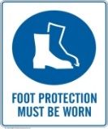 | 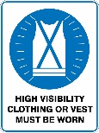 | 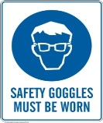 | 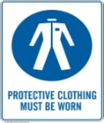 |  | 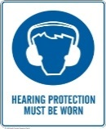 |  | 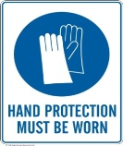 | 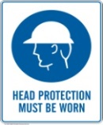 |  |  | 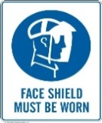 | 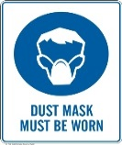 | 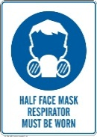 |  | 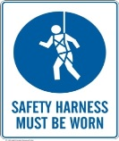

Activity  List the tasks required to perform the activity in the sequence they are carried out | Hazards  Against each task list the hazards that could cause injury when the task is performed | Inherent Risk Rating | Risk Control Measures  List the control measures required to eliminate or minimize the risk of injury arising from the identified hazard/s | Residual Risk Rating | Who is Responsible  Write the name of the person responsible to implement the control measure identified | Not Applicable to Work Site
 |  |  |  |  |  | Not Applicable
 |  |  |  |  |  | Not Applicable
 |  |  |  |  |  | Not Applicable
 |  |  |  |  |  | Not Applicable
 |  |  |  |  |  | Not Applicable
 |  |  |  |  |  | Not Applicable
 |  |  |  |  |  | Not Applicable
 |  |  |  |  |  | Not Applicable
 |  |  |  |  |  | Not Applicable
 |  |  |  |  |  | Not Applicable

Additional Staff Inducted Into Safe Work Method Statement Attach additional sheets if required
Name | Signature | Inducted By (Name) | Inducted By Signature | Date

Likelihood Consequence
Descriptor | Outcome Description
Rare | Remote possibility (less than once every 5+ years)
Unlikely | Not expected to occur (may occur 1-5 years)
Possible | Occurs occasionally (monthly – yearly)
Likely | Occurs regularly (weekly – monthly)
Almost certain | Expected to occur (daily – weekly)
Descriptor | Outcome Description
Insignificant | No injuries
Minor | On-site first aid treatment
Moderate | Medical treatment required, loss of time
Major | Serious injury, hospitalisation
Catastrophic | Death, permanent disability

Risk Rating
Likelihood | Consequence
 | Insignificant | Minor | Moderate | Major | Catastrophic
Rare | L | L | L | M | H
Unlikely | L | L | M | M | H
Possible | L | M | M | H | E
Likely | M | H | H | E | E
Almost certain | M | H | E | E | E

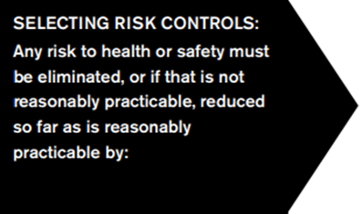 | 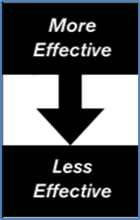  - Implementing any mandated controls specified by law (e.g. the OHS Regulations 2017)  - Substituting a new activity, procedure, plant, process or substance (e.g. scaffold in preference to ladders)  - Isolating persons from the hazard (e.g. fence off areas for mobile plant operation)  - Using engineering controls (e.g. guard rails, trench shields) - or a combination of the above.  If any risk to health or safety remains, it must be reduced by using:  - Administration controls (e.g. activity specific safety training, work instructions, warning signs)  - PPE such as respiratory protection, hardhats, high visibility clothing, or a combination of these.

